Student Management System
Documentation

1. Overview
The Student Management System is a PostgreSQL-backed system designed to manage student records, academic progress, course enrollments, and teacher information within an educational institution.
It supports:
- Student and teacher management
- Course scheduling
- Grade tracking
- Feedback collection
- Staff roles
This project was implemented using:
- PostgreSQL as the relational database
- Node.js + Express.js for the backend API
- HTML/CSS/JavaScript for the frontend UI
2. Features
Feature | Description
Student Registration | Add new students with basic info
Teacher Registartion | Add Faculty members with department
Department Management | Manage the Departments
Course Management | Define Courses

3. Database Schema Overview

Table | Description
departments | Stores academic departments
teachers | Faculty member data
students | Student records
courses | Academic courses offered
enrollments | Links students to courses
grades | Final grades for each course
course_prerequisites | Defines prerequisite courses
course_materials | "Upload syllabi videos etc."
exams | Exam definitions
exam_results | Exam score per student
timetables | Class schedules
feedback | Student feedback on teaching
staff | "Non-teaching staff (admins librarians)"

4. Entity Relationship Diagram (ERD)
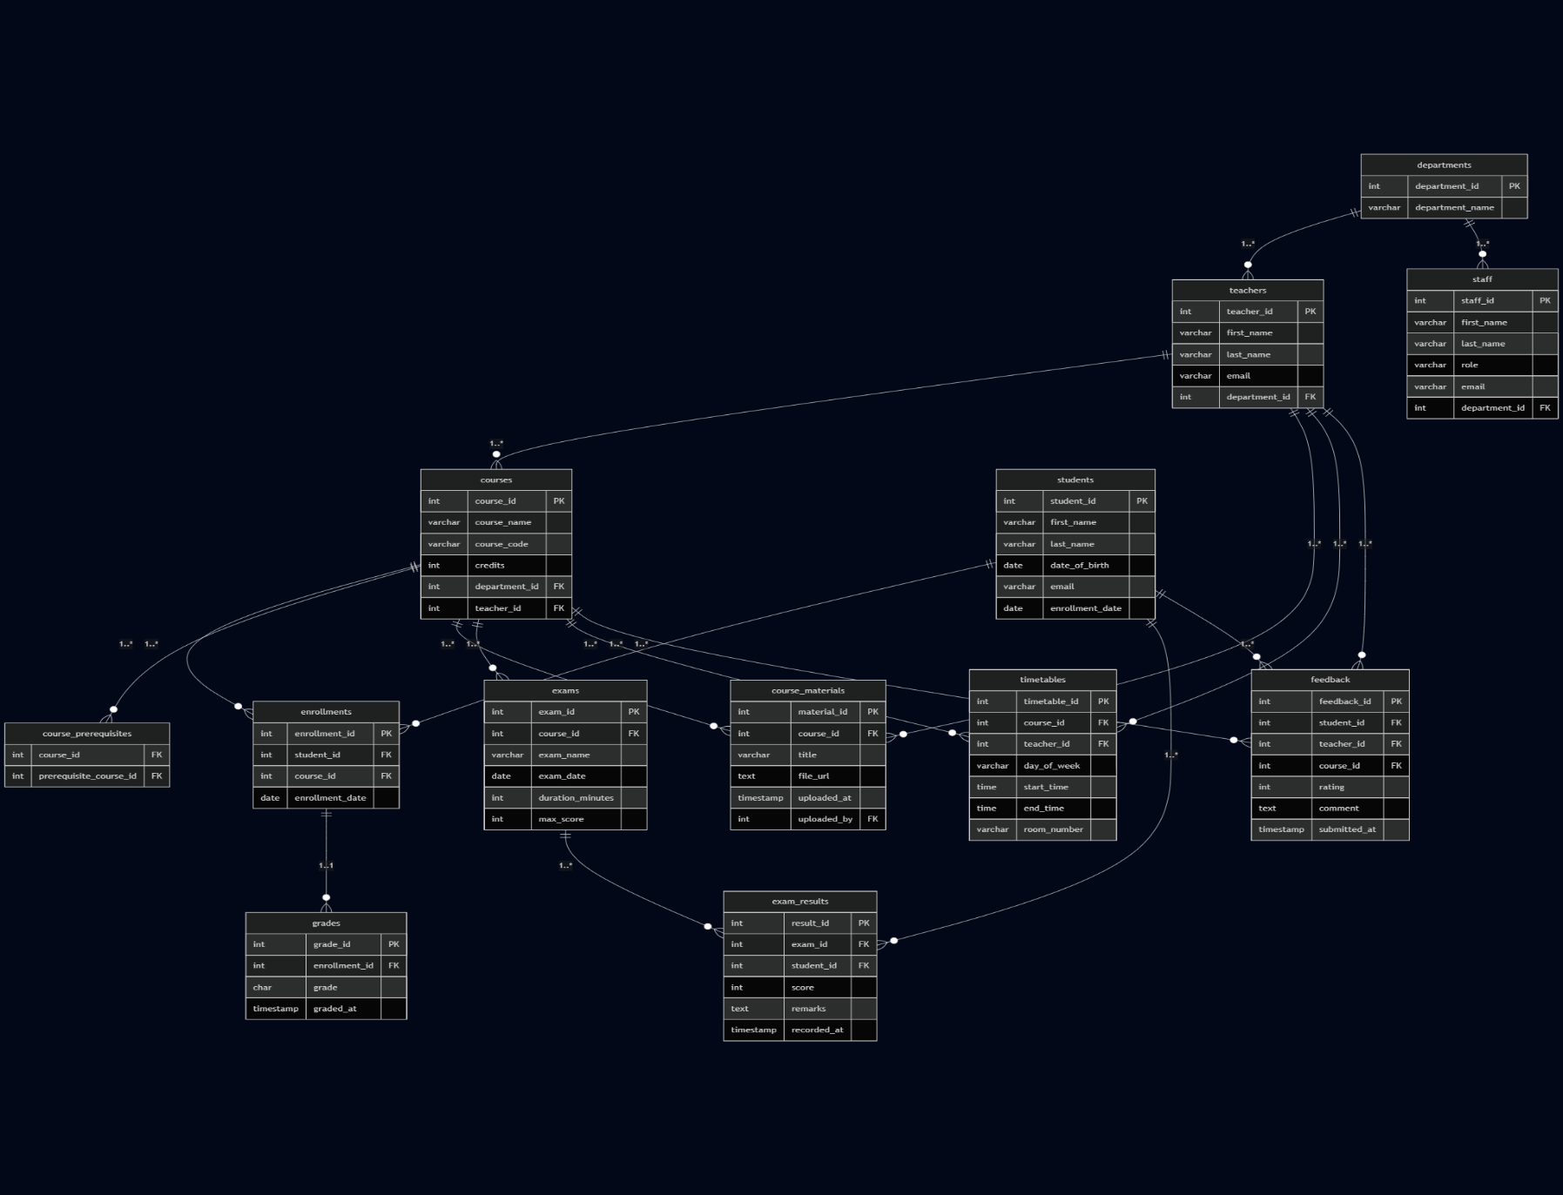

5. API Endpoints
Endpoint | Purpose
/departments | Get all departments
/teachers | Get all teachers
/students | Get all students
/courses | Get all courses
/enrollments | Get all enrollments
/grades | Get all grades
/prerequisites | Get all course prerequisites
/materials | Get all course materials
/exams | Get all exams
/results | Get all exam results
/timetables | Get all timetable entries
/feedback | Get all feedback
/staff | Get all staff members

POST Endpoints
Endpoint | Purpose
/departments | Add new department
/teachers | Add new teacher
/students | Add new student
/courses | Add new course
/enrollments | Enroll student in a course
/grades | Add grade for enrollment
/prerequisites | Add course prerequisite
/materials | Add course material
/exams | Add exam
/results | Add exam result
/timetables | Add class schedule
/feedback | Add student feedback
/staff | Add staff member

6. Technologies Used
Technology | Use
PostgreSQL | Database
Node.js | Backend server
Express.js | RESTful API framework
HTML/CSS/JS | Frontend interface
pg | PostgreSQL client for Node.js

